Online Movie Ticket Booking System

**AN INTERNSHIP REPORT**

***Submitted by***

**Aayushi Barot**

**200405021002**

**IN PARTIAL FULLFILLMENT FOR THE AWARD OF THE DEGREE OF**

**Integrated Master of Science & Information Technology**

**College of Computer Application Silver Oak University**



# Silver Oak University, Ahmedabad May, 2024

A Project Report On

**Internship In Techmicra IT Solution**

Post-Graduation Integrated M.Sc.IT

Silver Oak College of Computer Application

Submitted to:



Department of Masters

Silver Oak College of Computer Application Silver Oak University

Submitted By: Under the Guidance of

Aayushi Barot Asst. Prof. Sadik Lakhani

[200405021002] Department of Masters College of Computer Application

# Abstract

The purpose of ONLINE MOVIE TICKET BOOKING SYSTEM is to automate the existing manual system by the help of computerized equipment and full-fledged computer software, fulfilling their requirements, so that their valuable data information can be stored for a longer period with easy accessing and manipulation of the same. The required software and hardware are easily available and easy to work with.

ONLINE MOVIE TICKET BOOKING SYSTEM, as described above, can lead to error free, secure, reliable and fast management system. It can assist the user to concentrate on their other activities rather to concentrate on the record keeping. Thus, it will help people in better utilization of resources. The application can maintain computerized records without redundant entries. That means that one need not be distracted by information that is not relevant, while being able to reach the information.

# Preface

Welcome to the preface of " ONLINE MOVIE TICKET BOOKING SYSTEM," a comprehensive content management system (CMS) developed for our final year university project. This project encapsulates the culmination of our academic journey, reflecting our passion for innovative web technologies and e-commerce solutions.

The idea behind Pixel Pulse emerged from our shared enthusiasm for gaming and technology. We envisioned a platform that not only showcases the latest consoles and accessories but also provides a seamless shopping experience for gamers and enthusiasts alike. Through this CMS, we aimed to integrate cutting-edge features with a user-friendly interface to simulate a real-world e-commerce environment.

Our approach to developing Pixel Pulse was centered around leveraging robust web technologies and best practices in software engineering. From

conceptualization to implementation, we strived to adhere to industry standards and incorporate scalable design principles. This CMS represents a synthesis of our academic learnings and practical skills, demonstrating our ability to tackle complex challenges in the realm of web development.

This preface sets the stage for a detailed exploration of Pixel Pulse, highlighting its architecture, functionalities, and the methodologies employed during its

development. We invite you to delve into the subsequent chapters to discover the intricacies of this project and gain insights into our problem-solving strategies and creative innovations.

We extend our gratitude to our mentors, professors, and peers whose guidance and support have been instrumental in bringing Pixel Pulse to fruition. Lastly, we dedicate this project to the community of technology enthusiasts and e-commerce aficionados, with the hope that Pixel Pulse will inspire future endeavors in the ever-evolving landscape of web development.

Thank you for joining us on this journey through Pixel Pulse: A Console Selling Store.

# Acknowledgement

We Express Our Heart Gratitude to A Number of People Who Extended Their Full Support and Cooperation in Developing This Project. Firstly, We Would Like to Take This Opportunity to Thank Our College **Silver Oak University** For Giving Us This Opportunity And A Platform For Discovering And Developing Our potential, The King Of Experience That We Have Received While Making This Project Report Is So Immense That Narrating That In Few Word Is Difficult.

After Putting in Such a Hard-work We Have Realized That Takes To Work In Company And Do A Project. Our Project name is ***Internship in Techmicra IT Solutions*** And Colleagues have been Great Source of Help without Them We Were Unable to Do This Project. There for our Project. As If Small Drop of Water of Sea. We Have Learnt Many Things from Being a Part of Concept Family.

After That Our Heartiest Thanks to Our Guide as Well as Respected ***Internal Guide Prof. Sadik Lakhani, HoD Prof. Risha Tiwari, Principal Dr. Hemal U. Patel, Dean Prof. Sagar Patel and Mentor Prof. Nilesh Brahmkshatriya.*** For Entrusting Upon Us the Responsibility and Acting as Ray of Light in Darkness. We Find Our Self-Short of Words to Describe Our Feeling for the Role they played Of Friends, A Philosophers and Guide, Whenever We Were in Need.

Lastly, We Are Thank Full to Our Parents Without Their Blessing, Love, And Support We Are Unable to Traverse Through This Most Significant Stage of Life. And also, We Would Like to Take This Opportunity to Express Our Regards to All Friends and Faculties Who Have Helped Us Directly Or Indirectly During The Execution Of The Project. We Are Privileged and Thankful to All In Bringing Out Errors And Shortcoming.



**SILVER OAK COLLEGE OF COMPUTER APPLICATION**

# Department of Masters Integrated M.Sc.IT

**College Of Computer Application 2023-24**

**CERTIFICATE**

**Date: 15 / 04 /2024**

This is to certify that the project entitled **ONLINE MOVIE TICKET BOOKING SYSTEM** has been carried out by **Aayushi Barot (200405021002)** under the guidance of **Asst. Prof. Sadik Lakhani** in fulfilment of the **SOCCA** – **Industry Internship-II (1040235492)**, 8th Semester, Degree of **Integrated M.Sc.IT** of Silver Oak College of Computer Application, Silver Oak University, Ahmedabad during the academic year 2023-2024.

Internal Guide: Prof. Sadik Lakhani HOD: Prof. Risha Tiwari

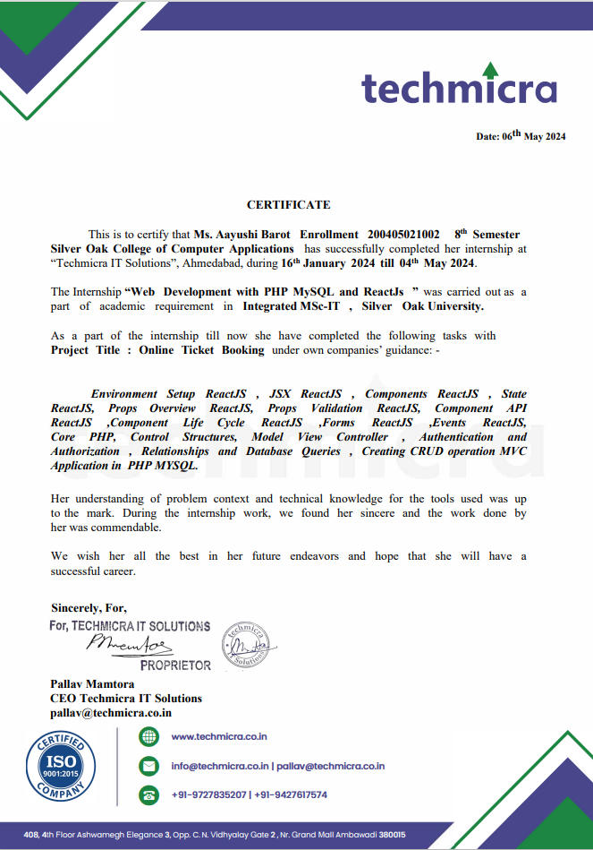

**Index**

|  |  |  |  |
| --- | --- | --- | --- |
| Sr. No | Title | | Page No. |
| 1. | Project Title | | 9 |
| 2. | Problem Definition | | 10 |
| 3. | Need of Project | | 11 |
| 4. | Requirement | | 12 |
| 5. | Technology used | | 13 |
| 6. | Functional and Non- Functional Dependency | | 13 |
| 7. | Introduction | | 14 |
| 8. | Design | |  |
|  | 8.1 | System Flow Diagram: | 15 |
|  | 8.2 | USE CASE Diagram | 16 |
|  | 8.3 | Activity Diagram | 17 |
|  | 8.4 | Sequence & Class Diagram | 20 |
|  | 8.5 | ER Diagram | 24 |
|  | 8.6 | Data Dictionary | 25 |
|  | 8.7 | Screenshots of Module | 34 |
| 9. | Application | | 48 |
| 10. | Expected Outcomes: | | 49 |
| 11. | Future Scope | | 50 |
| 12. | References | | 51 |

1. **Project Title:**

**ONLINE MOVIE TICKET BOOKING SYSTE**

# Problem Definition:

The problem definition for a Content Management System (CMS) typically addresses the challenges faced by individuals or organizations in managing digital content. A CMS aims to solve issues such as:

* Content Creation: Simplifying the process of creating content without needing technical expertise.
* Content Storage: Organizing content in a way that is secure, scalable, and easily retrievable.
* Content Publishing: Streamlining the process of making content live on a website with minimal steps.
* Content Modification: Allowing for easy updates and edits to content, often with version control.
* User Access Control: Managing permissions for different users to access certain content or features within the CMS.
* Content Distribution: Ensuring content can be delivered across various channels and devices efficientl

# Need of Project:

The need for a CMS project arises from the necessity to efficiently manage and deliver content. Here are some key reasons why a CMS project is essential:

**Streamlined Content Management**: A CMS allows for easy content creation, editing, and deletion, making it simpler for non-technical users to maintain website content.

**Collaboration:** Multiple users can work on content simultaneously, with various permission levels to control access and editing rights.

**Consistency:** Ensures a consistent appearance for all the content across the website, which is crucial for brand identity and user experience.

**SEO Optimization:** A good CMS will support SEO best practices to help improve the visibility of the website in search engine results.

**Cost-Effectiveness:** Reduces the need for expensive technical resources for everyday content updates and site maintenance.

**Scalability:** Can grow with the business, accommodating more content and more complex functionalities as needed.

**Regulatory Compliance:** Helps in adhering to data protection and privacy laws by managing how content is stored and displayed

**4 .Requirement**

**Server-Side Requirements:**

* **Hardware Requirements:**

1. **Processor: Multi-core processor (e.g., Intel Core i5 or better)**
2. **RAM: Minimum 2GB (4GB+ recommended for better performance)**
3. **Storage: SSD storage recommended for faster read/write operations**
4. **Network: Stable internet connection with sufficient bandwidth for expected user traffic**
   * **Software Requirements:**
5. **Operating System: Linux (e.g., Ubuntu, CentOS), Windows Server**
6. **Web Server: Apache, Nginx**
7. **Database: MySQL, PostgreSQL, MongoDB (depending on CMS requirements)**
8. **Programming Language: PHP, Python, Node.js (based on CMS platform)**
9. **CMS Platform: WordPress, Joomla, Drupal, etc.**
10. **Security: SSL certificate for HTTPS, firewall configurations**
11. **Additional Tools: Content delivery network (CDN) for optimized content delivery**

**Client-Side Requirements:**

* + **Hardware Requirements:**

1. **Device: Desktop, laptop, tablet, or smartphone**
2. **Processor: Modern processor for smooth rendering and interaction**
3. **RAM: Typically 2GB or more for better multitasking**
   * **Software Requirements:**
4. **Operating System: Windows, macOS, Linux, iOS, Android**
5. **Web Browser: Latest versions of Chrome, Firefox, Safari, Edge, or compatible browsers**
6. **Browser Plugins: JavaScript enabled, cookies enabled (as required by the CMS)**
7. **Internet Connection: Stable broadband or cellular connection**

**Additional Considerations:**

* + **Scalability: Ensure the server infrastructure can scale with increased traffic and content.**
  + **Backup and Recovery: Implement regular backups of CMS data and configurations.**
  + **Monitoring and Maintenance: Use monitoring tools for server health and CMS performanceA.**
  + **Accessibility: Ensure the CMS interface is accessible across different devices and screen sizes.**

1. **Web Server:** Apache, Nginx
2. **Database:** MySQL, PostgreSQL, MongoDB (depending on CMS requirements)
3. **Programming Language:** PHP, Python, Node.js (based on CMS platform)
4. **CMS Platform:** WordPress, Joomla, Drupal, etc.
5. **Security:** SSL certificate for HTTPS, firewall configurations
6. **Additional Tools:** Content delivery network (CDN) for optimized content delivery

**Client-Side Requirements:**

* + **Hardware Requirements:**

1. **Device:** Desktop, laptop, tablet, or smartphone
2. **Processor:** Modern processor for smooth rendering and interaction
3. **RAM:** Typically 2GB or more for better multitasking
   * **Software Requirements:**
4. **Operating System:** Windows, macOS, Linux, iOS, Android
5. **Web Browser:** Latest versions of Chrome, Firefox, Safari, Edge, or compatible browsers
6. **Browser Plugins:** JavaScript enabled, cookies enabled (as required by the CMS)
7. **Internet Connection:** Stable broadband or cellular connection

**Additional Considerations:**

* + **Scalability:** Ensure the server infrastructure can scale with increased traffic and content.
  + **Backup and Recovery:** Implement regular backups of CMS data and configurations.
  + **Monitoring and Maintenance:** Use monitoring tools for server health and CMS performanceA.
  + **Accessibility:** Ensure the CMS interface is accessible across different devices and screen sizes.

1. **Technology Used**

* Technology used:  
  Font End: HTML5, CSS3, JS, Bootstrap, jQuery
* Back End: PHP, MY SQL.

1. **Functional and Non- Functional Dependency:**

**Functional Dependencies:**

* **Content Operations:** The ability to create, read, update, and delete content.
* **User Management:** Managing user roles and access permissions.
* **Content Workflow:** A system for reviewing, approving, and publishing content.
* **Template Management:** Handling the design templates for content presentation.
* **Media Management:** Uploading and managing media files like images and videos.
* **Search Functionality:** Enabling users to search for content within the CMS.
* **Version Control:** Tracking changes to content over time.

**Non-Functional Dependencies:**

* **Performance:** The CMS should load content quickly and handle traffic efficiently.
* **Scalability:** It should be able to scale with the growth of content and users.
* **Security:** Protecting against unauthorized access and data breaches.
* **Usability:** The interface should be user-friendly and intuitive.
* **Compatibility:** Working well across different browsers and devices.
* **Maintainability:** The system should be easy to maintain and update.
* **Compliance:** Adhering to relevant legal and regulatory standards.

# Introduction:

* **HTML (Hypertext Markup Language)** is the standard markup language used to create web pages. It provides the structure of a webpage, allowing you to define elements like headings, paragraphs, links, and images.
* **CSS (Cascading Style Sheets)** is used to style and layout web pages. It lets you apply styles to HTML elements, such as colors, fonts, and spacing, and control the layout of multiple web pages with a single stylesheet.
* **JavaScript (JS)** is a scripting language that enables you to create dynamically updating content, control multimedia, animate images, and much more. It’s an essential part of web applications and enhances user interaction.
* **jQuery** is a fast, small, and feature-rich JavaScript library designed to simplify the client-side scripting of HTML. It was found in January 2006.
* **PHP (Hypertext Preprocessor)** is a server-side scripting language designed for web development. It’s used to manage dynamic content, databases, session tracking, and even build entire e-commerce sites.
* **MySQL** is a relational database management system based on SQL (Structured Query Language). It’s used to store, retrieve, and manage data in a database. It’s commonly used in conjunction with PHP to create dynamic web applications.

# Design:

* 1. **System Flow Diagram**

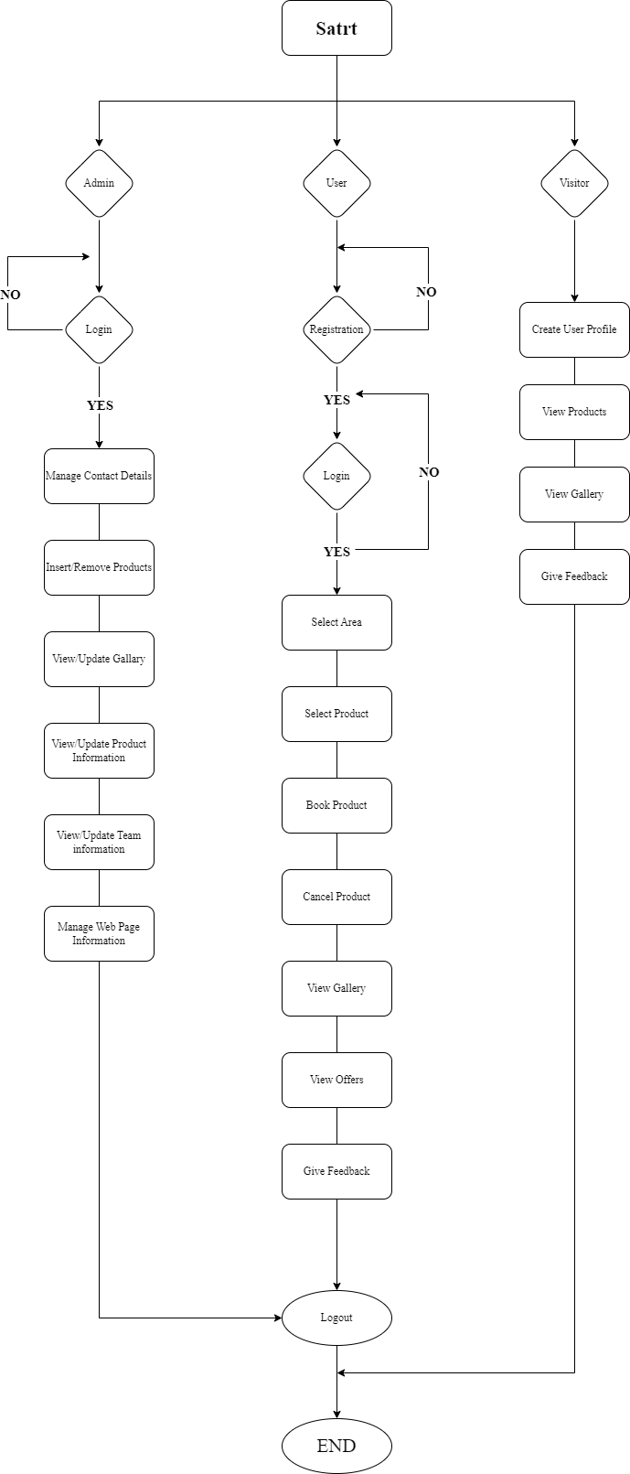

* 1. **USE CASE Diagram**

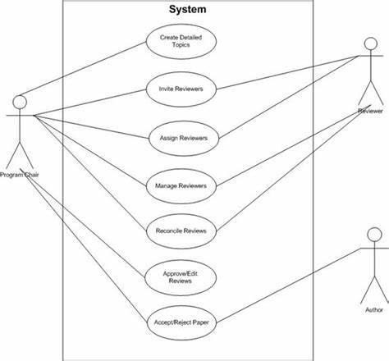

* 1. **Activity Diagram:**

**Activity Diagram of Admin**

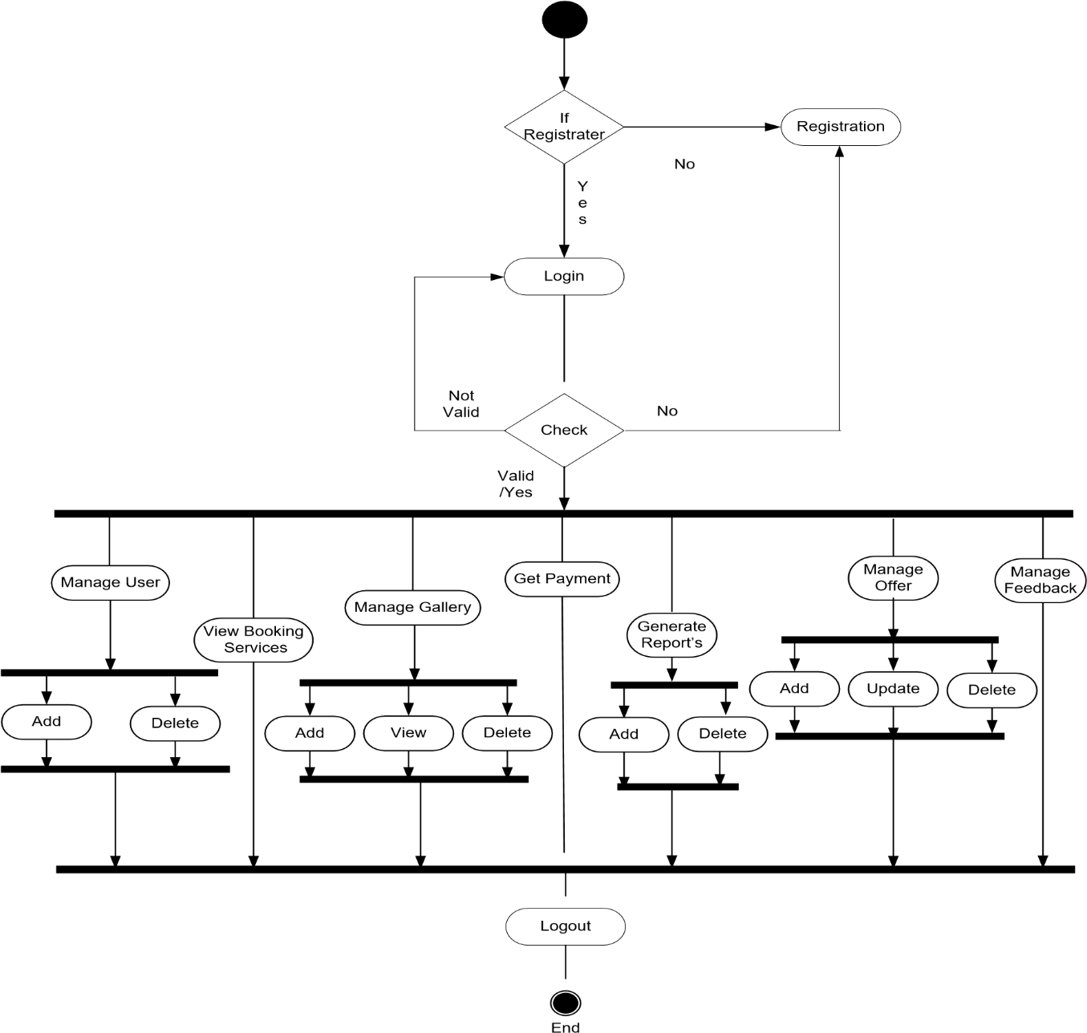

**Activity Diagram of User**

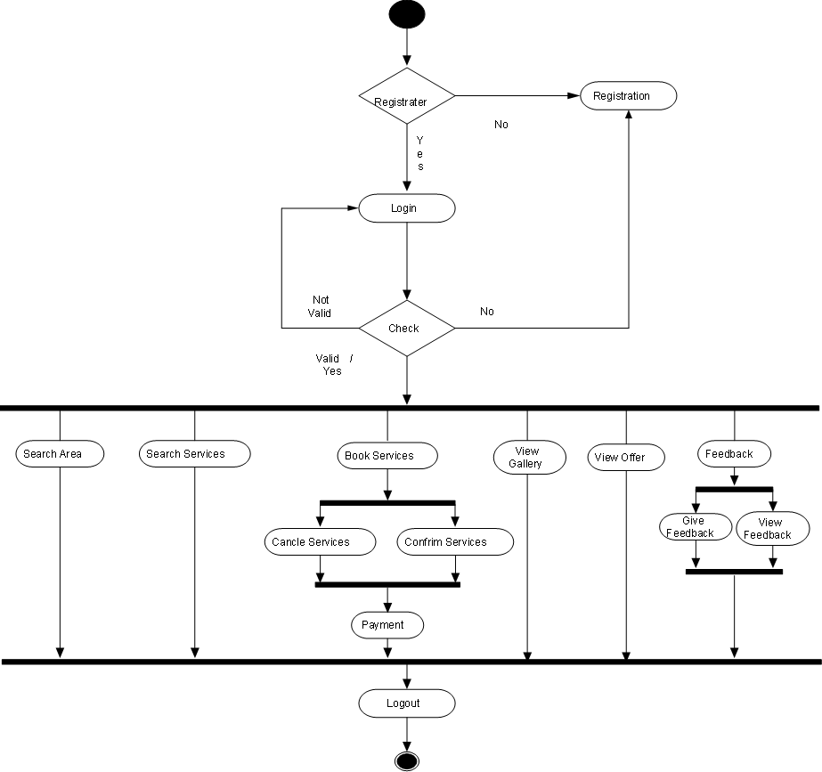

**Activity Diagram of Visitor**



Search Services

View Services

View Gallery

Contactus

* 1. **Sequence Diagram & Class Diagram**

**Sequence Diagrams**

**Sequence Diagram of Login**



Database

Login(Id /password)

Fetch Details

Login Successfully/Unsuccess

User(Id / password)

Login Details

Verify

Login Successfully/ Unsuccess

Fetch Details

Login Details

Verify

System

User

Admin

**Sequence diagram of Manage Services**

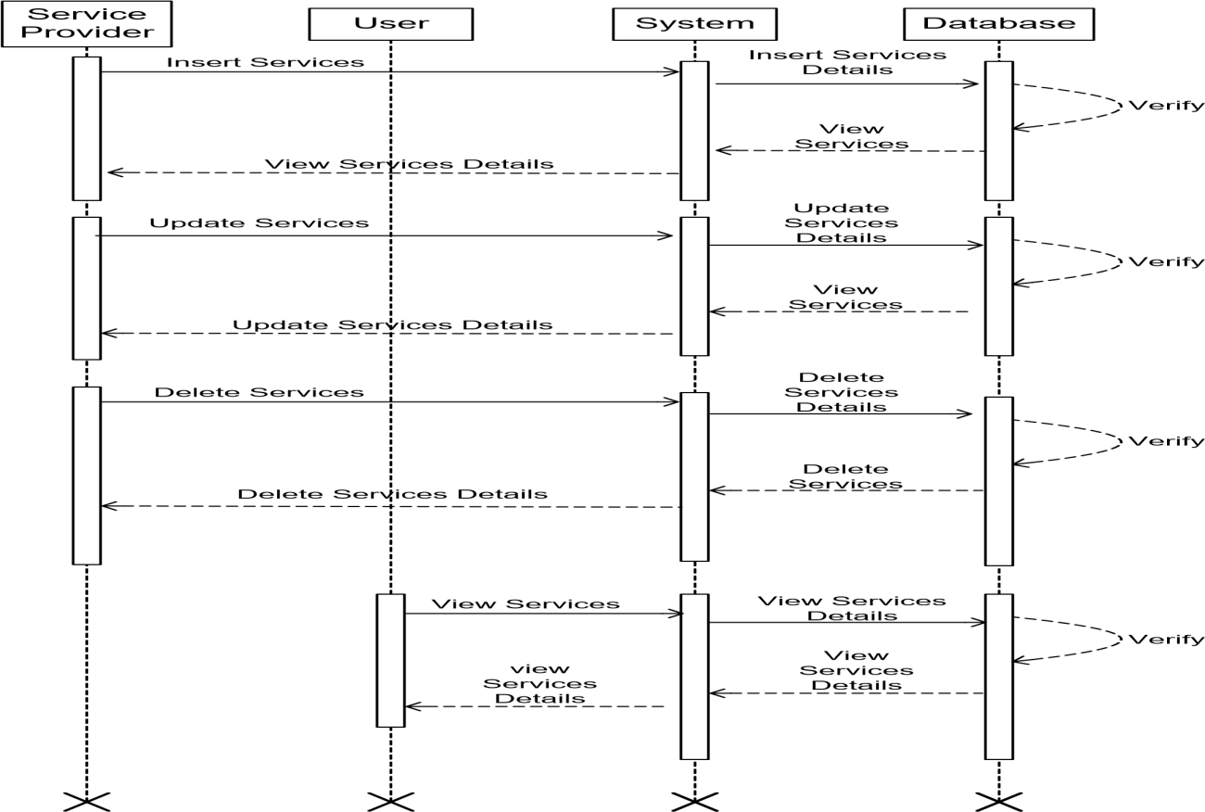

**Sequence diagram of Book Services**

Database



System

User

Service Provider

Search Services

Provide search Details

Get Search Services

Details

Provide search Details

Verify

Book Services

Book Services Details

Provide services Details

Verify

Provide services Details

Cancle Services

Cancle Services Details

Cancle Services

Cancle Services

Verify

Confirm Services

Confirm Services

Confirm Services Details

Confirm Services

Verify

Conform Services

Conform Services Details

Conform Services

Verify

Conform Services

**Class Diagram**

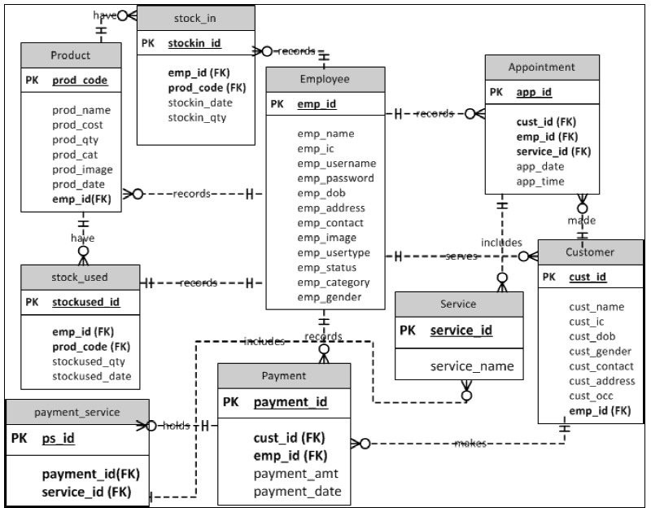

* 1. **ER Diagram:**

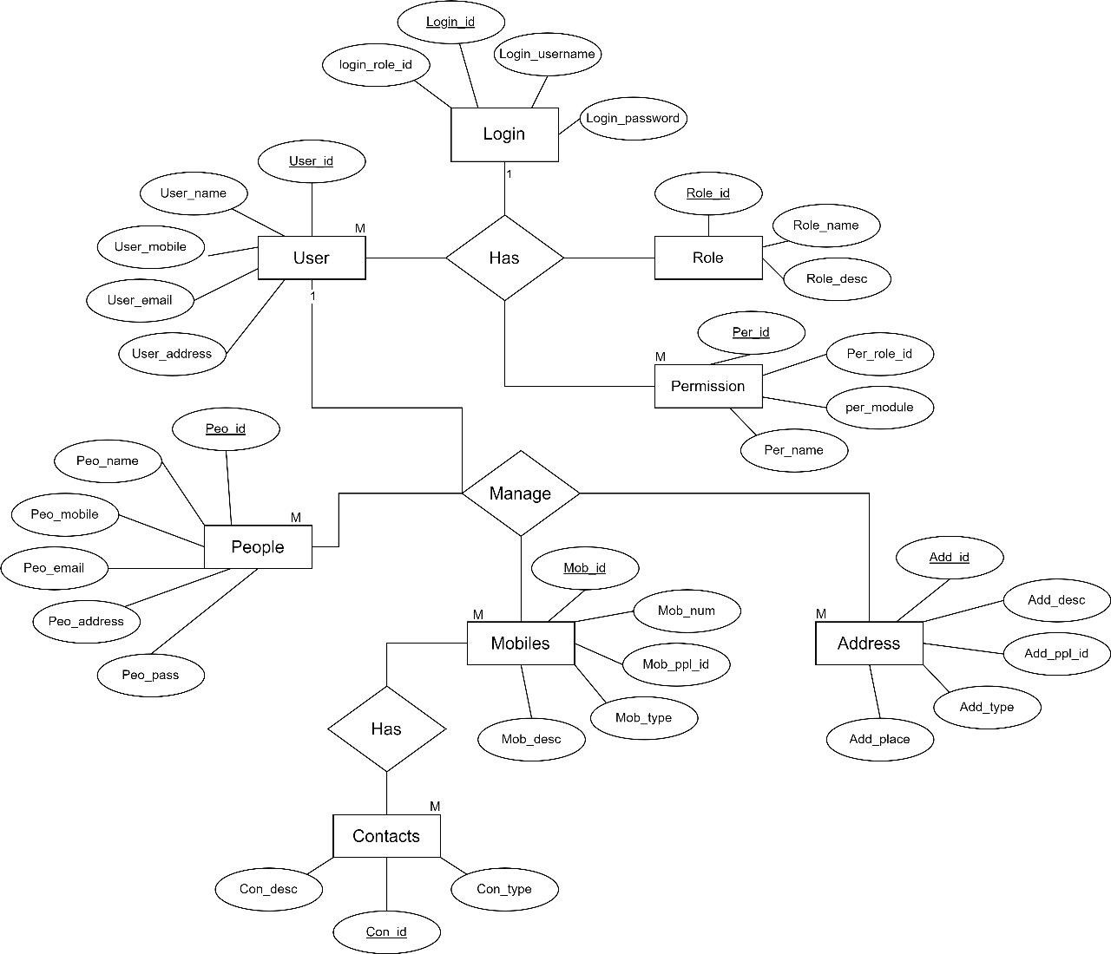

**DATABASE SCREENSHOTS:**

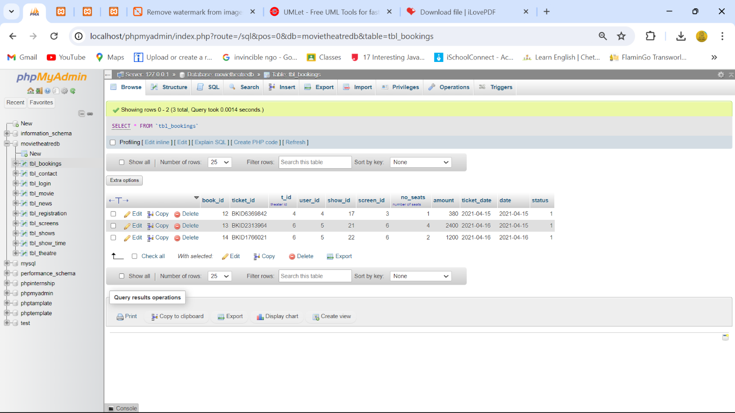

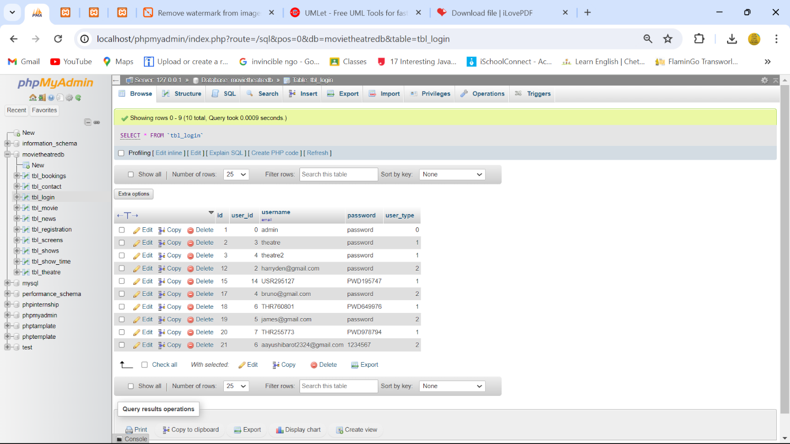

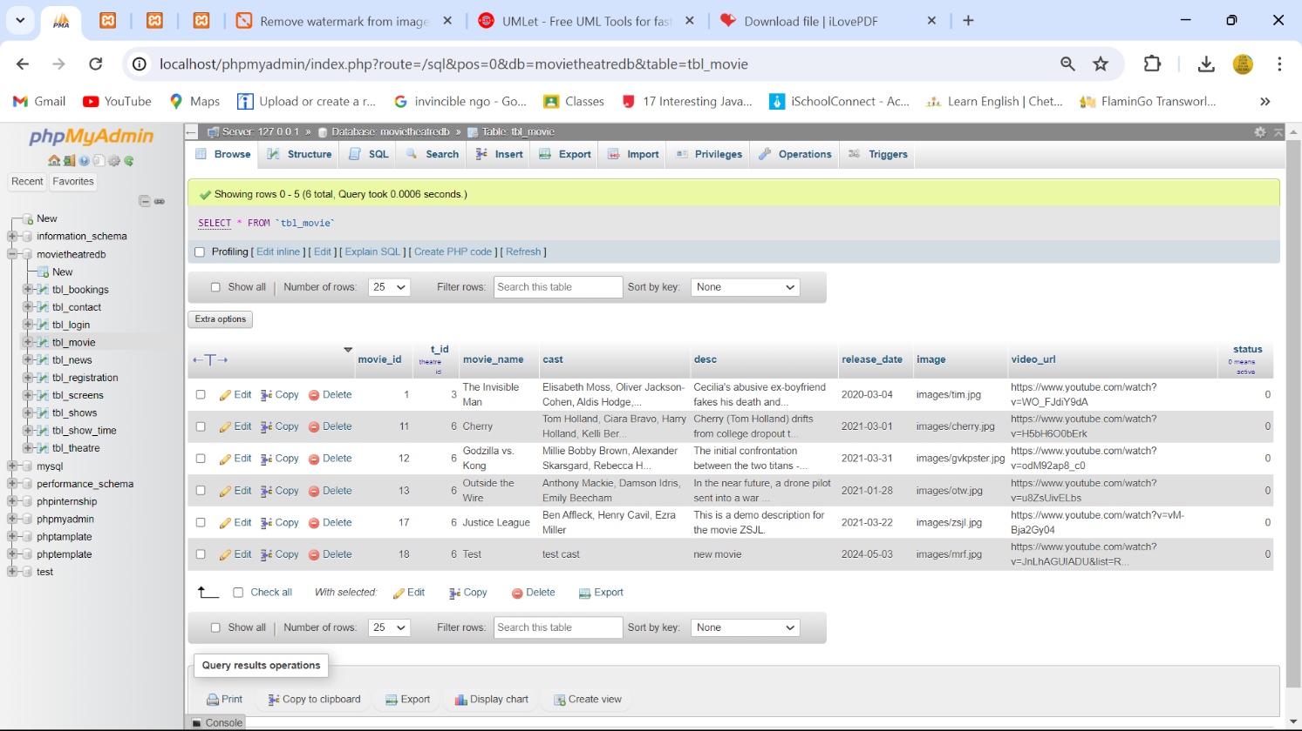

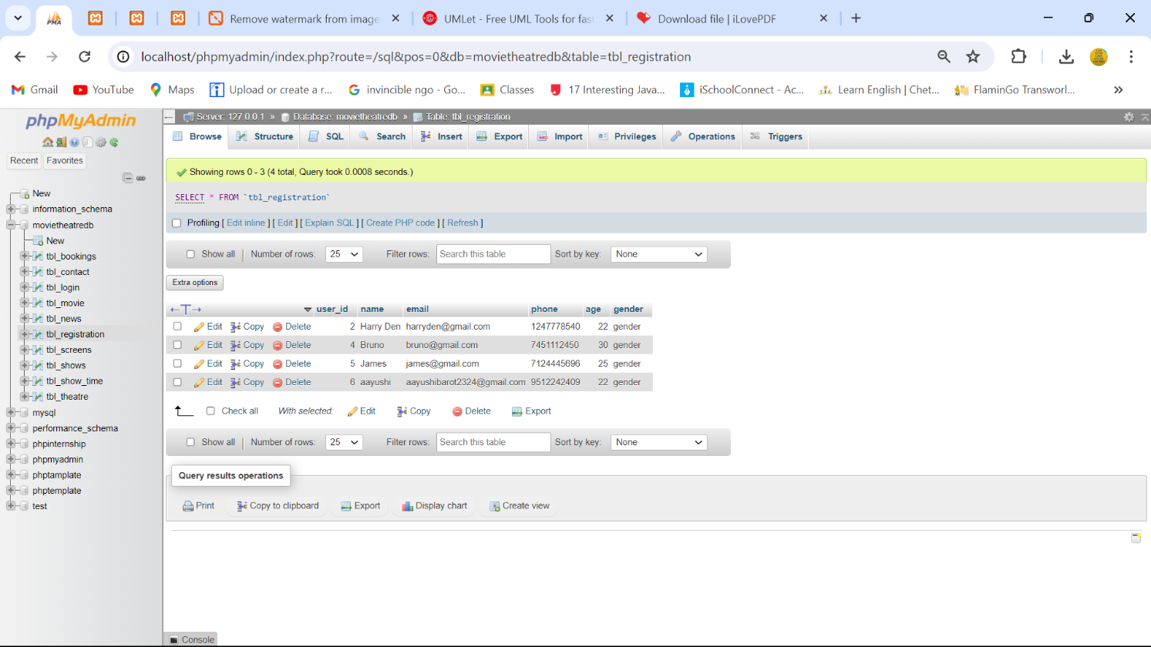

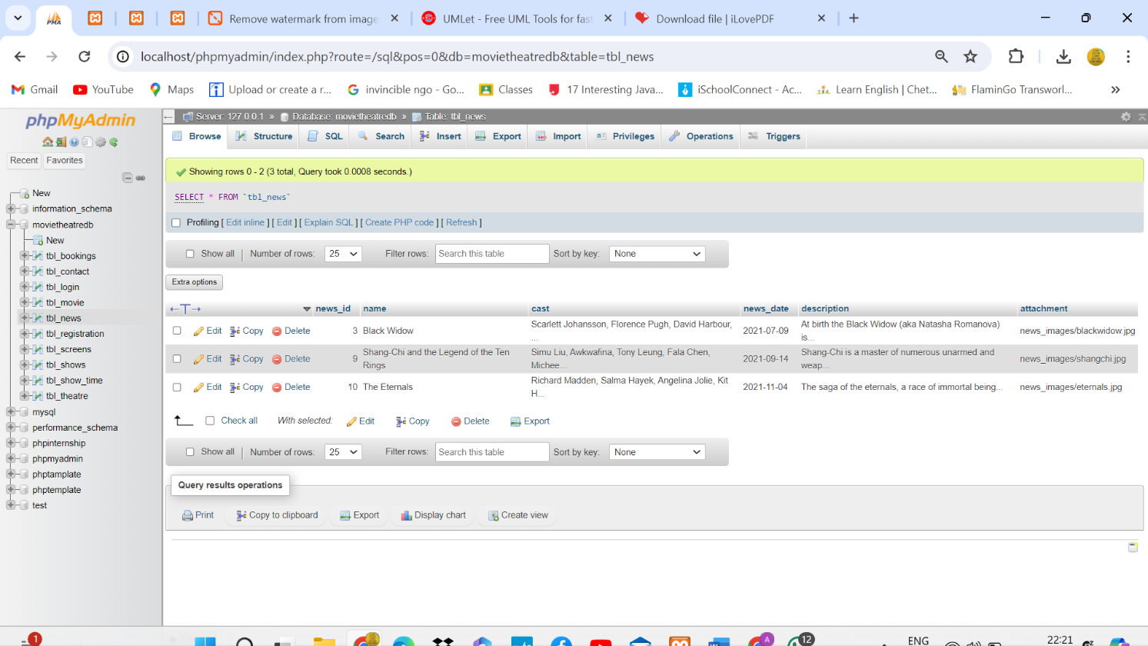



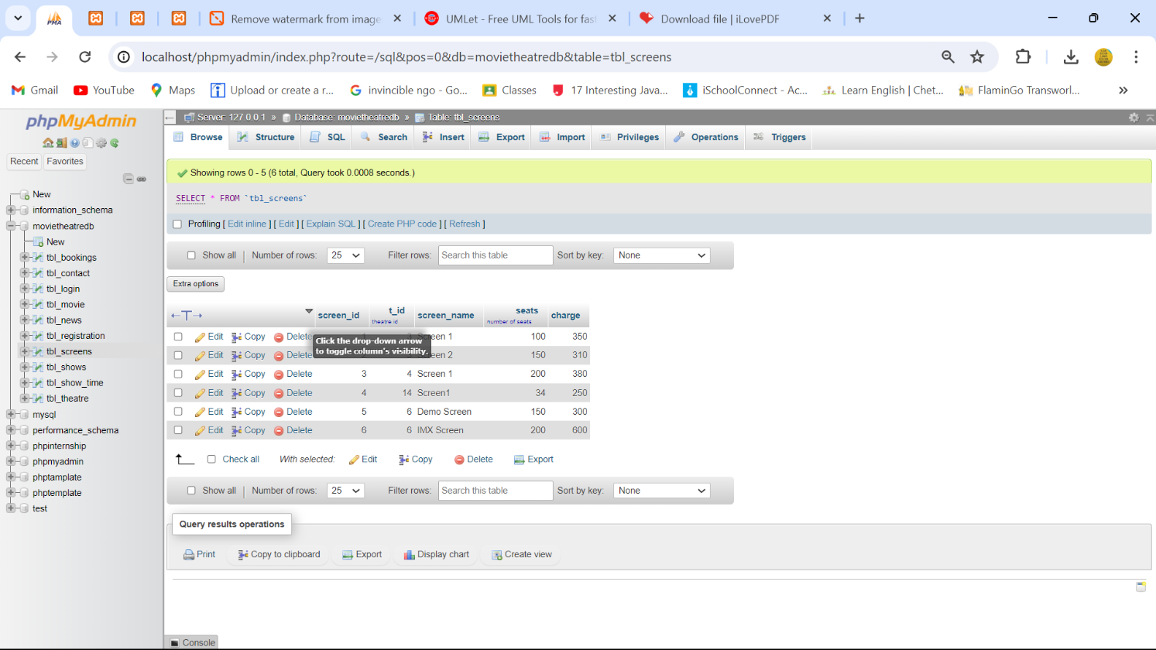

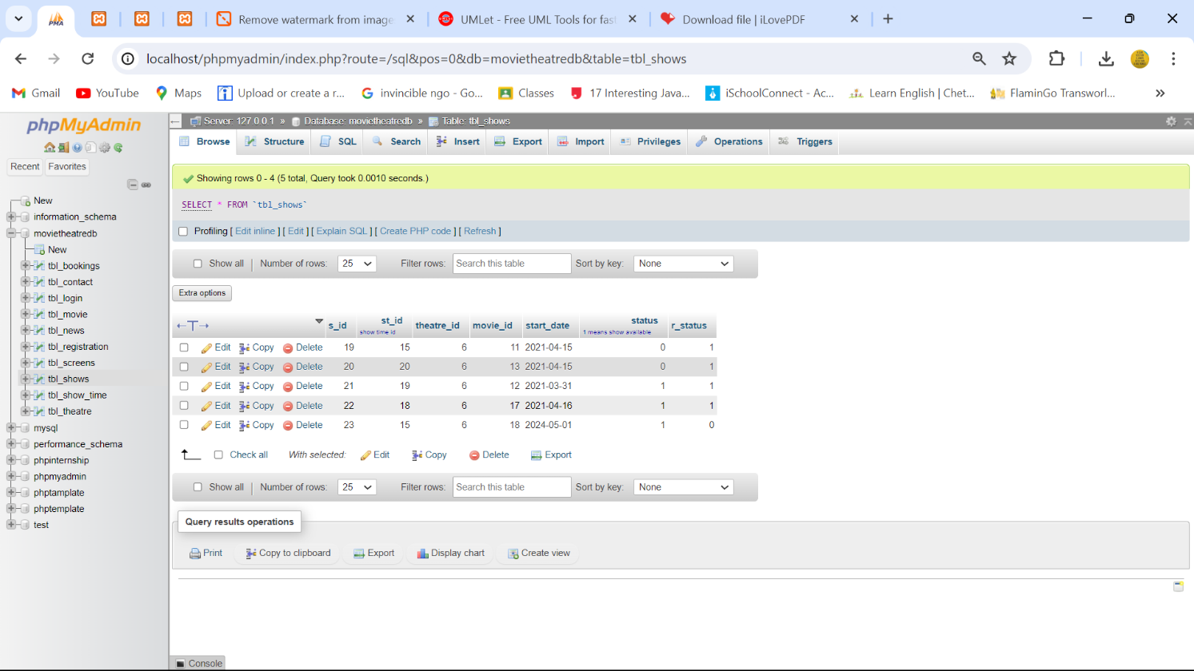

Day 6

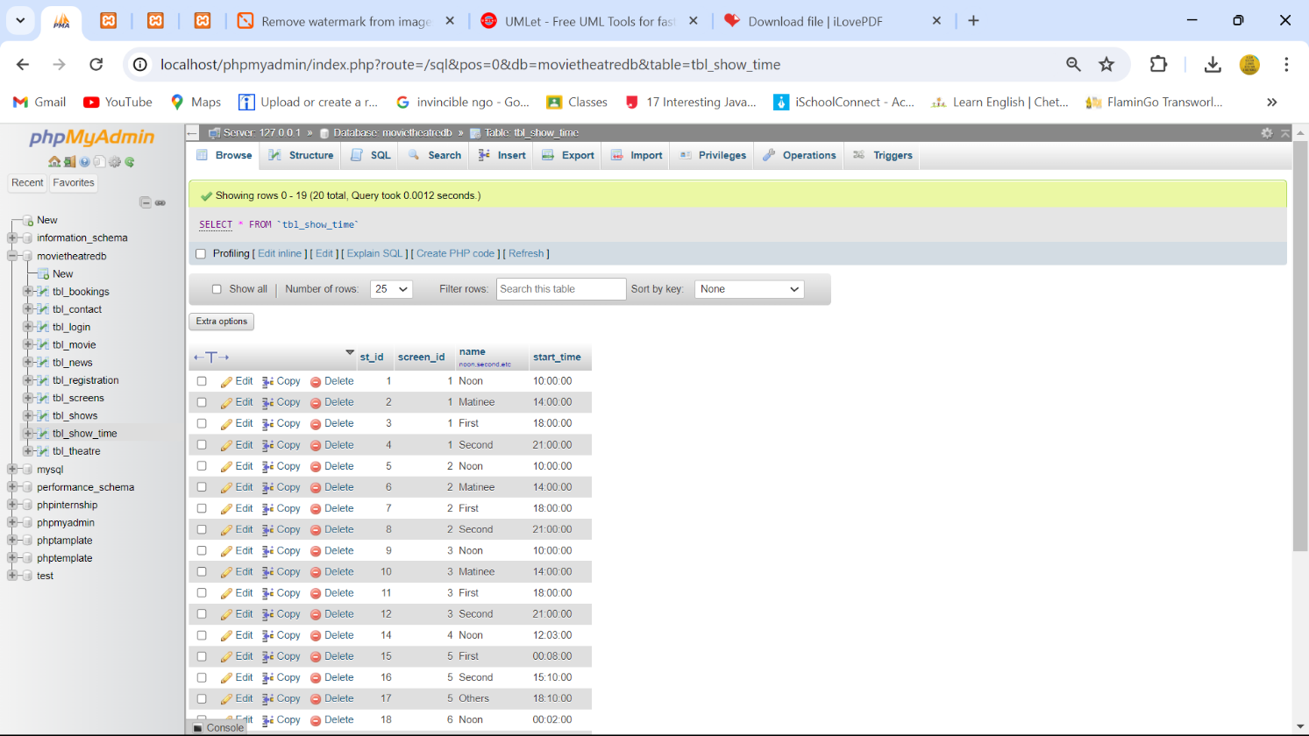

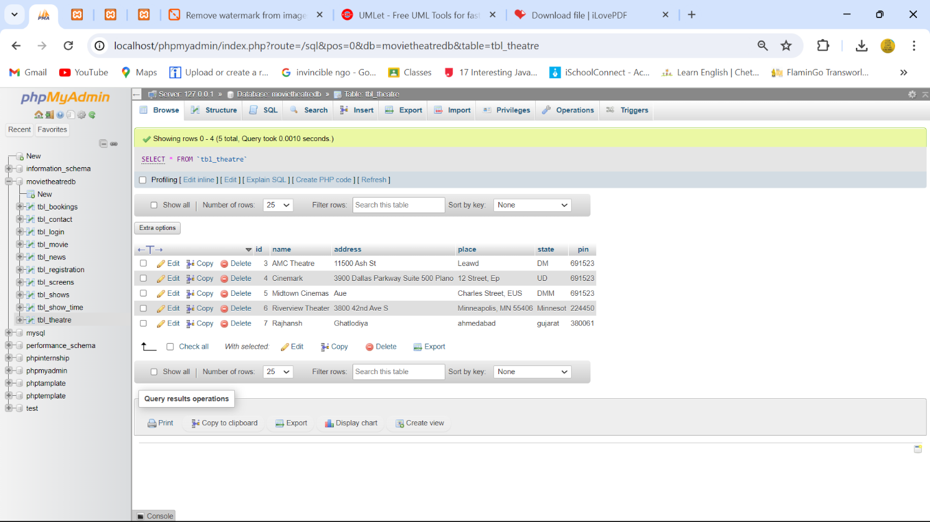

**LOGIN PAGE FOR ADMINISTRATOR:**

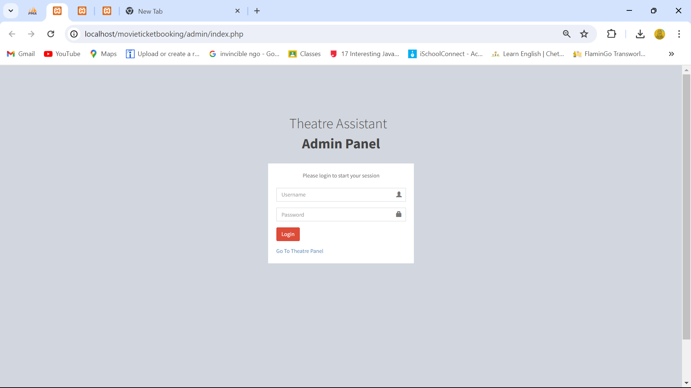

**LOGIN PAGE FOR THEATRE PANEL:**

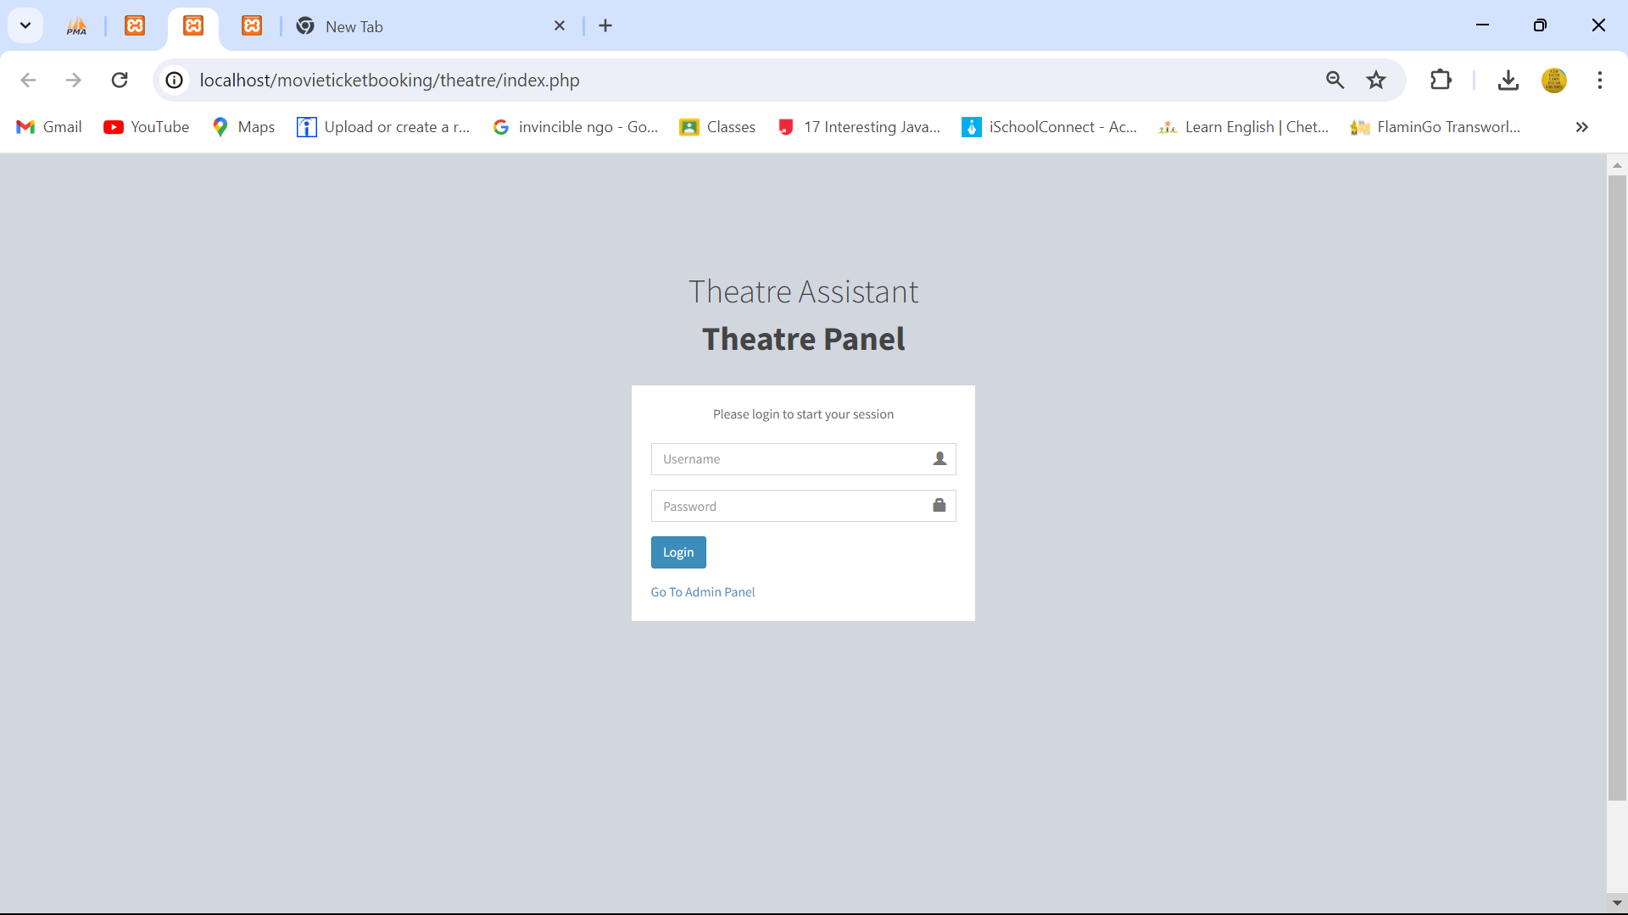

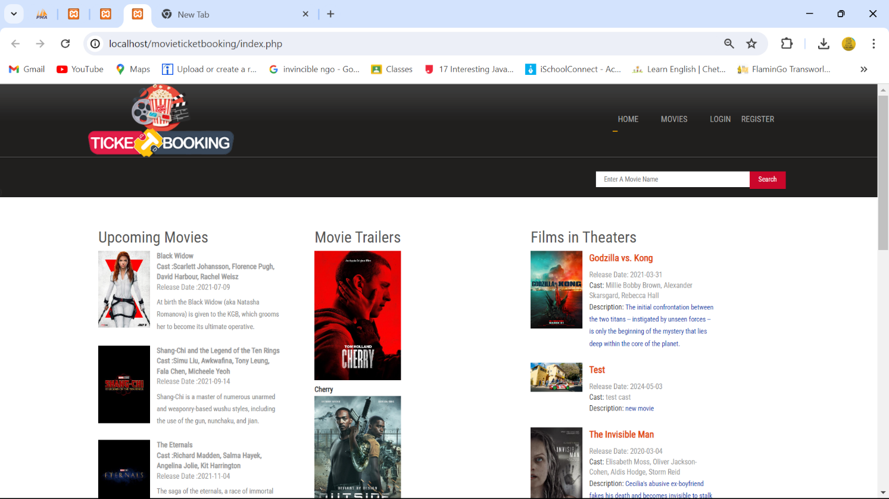

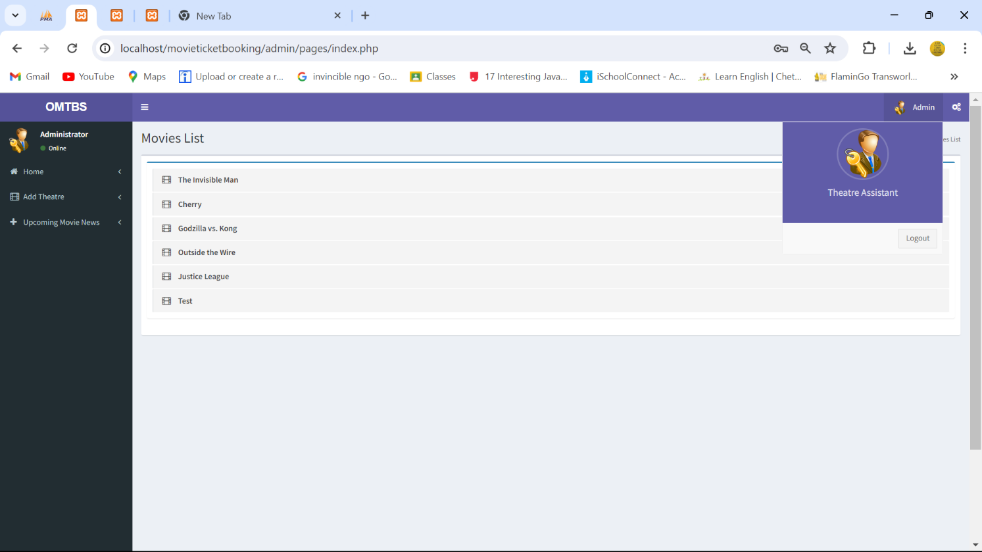

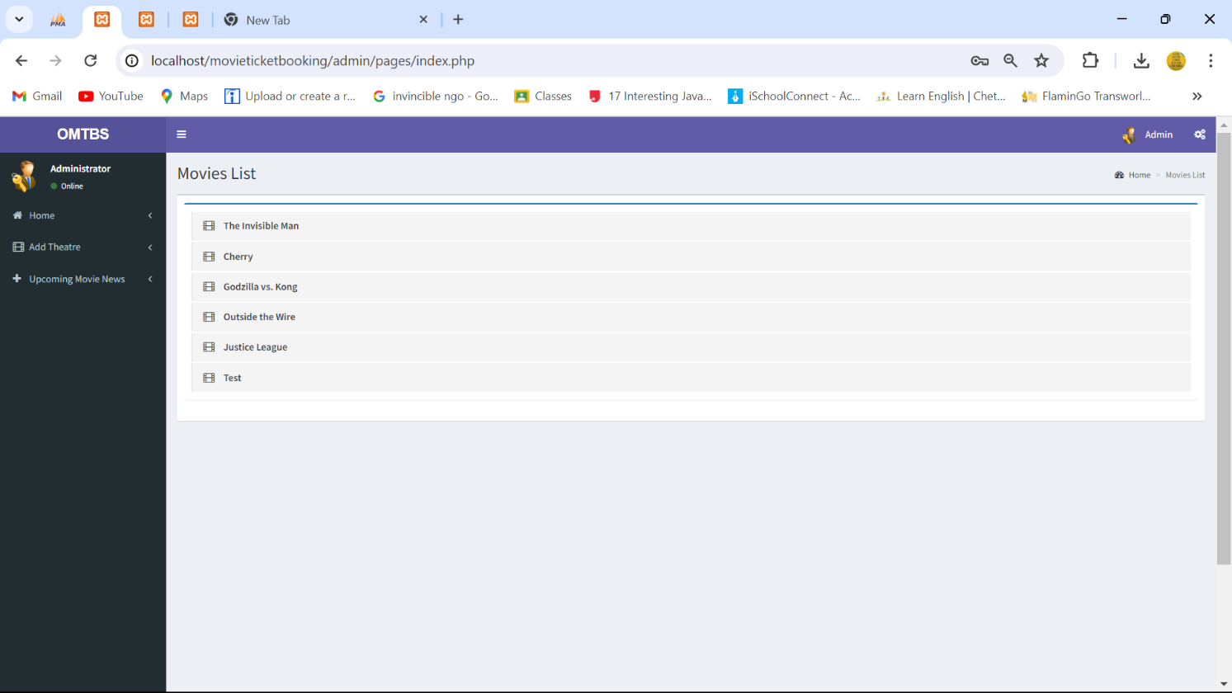

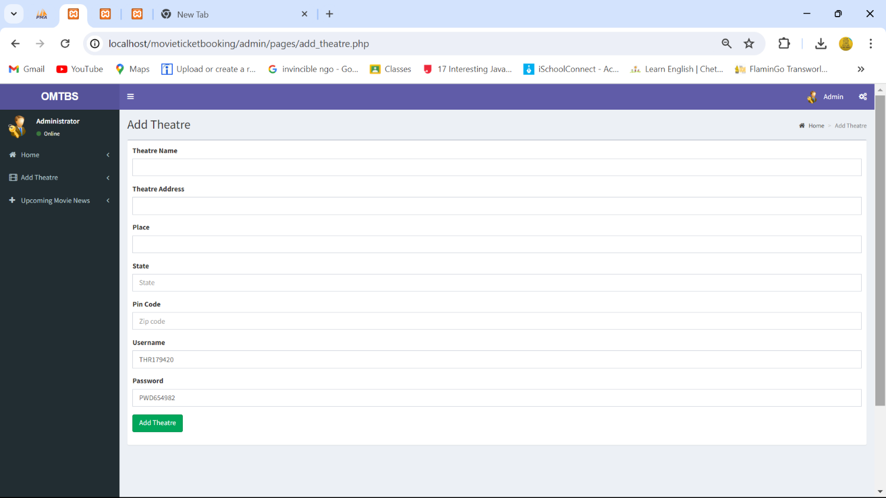

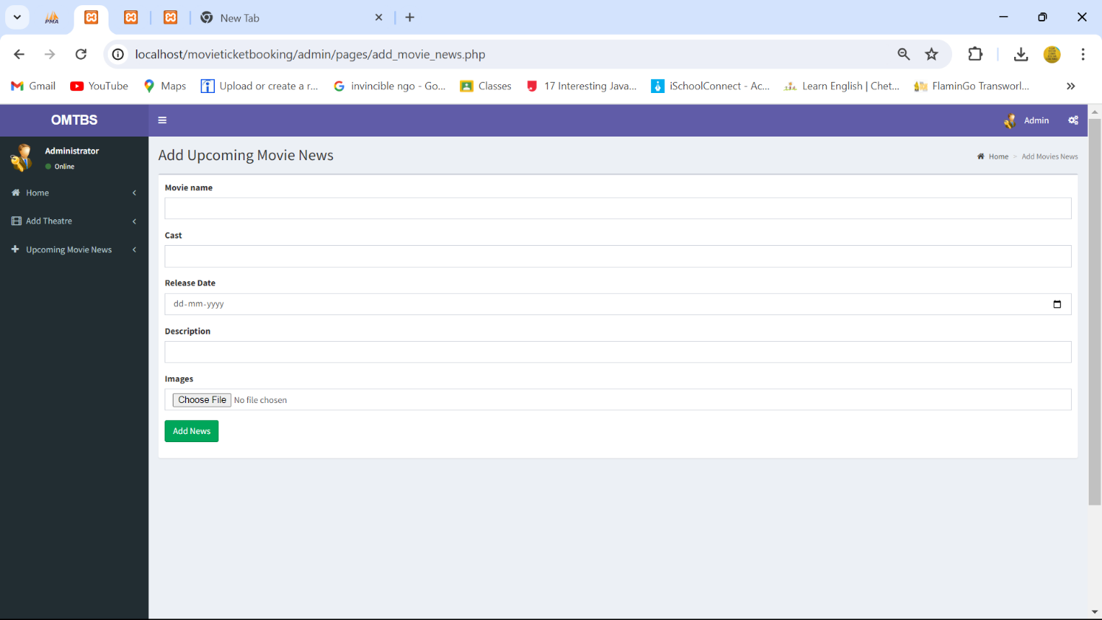

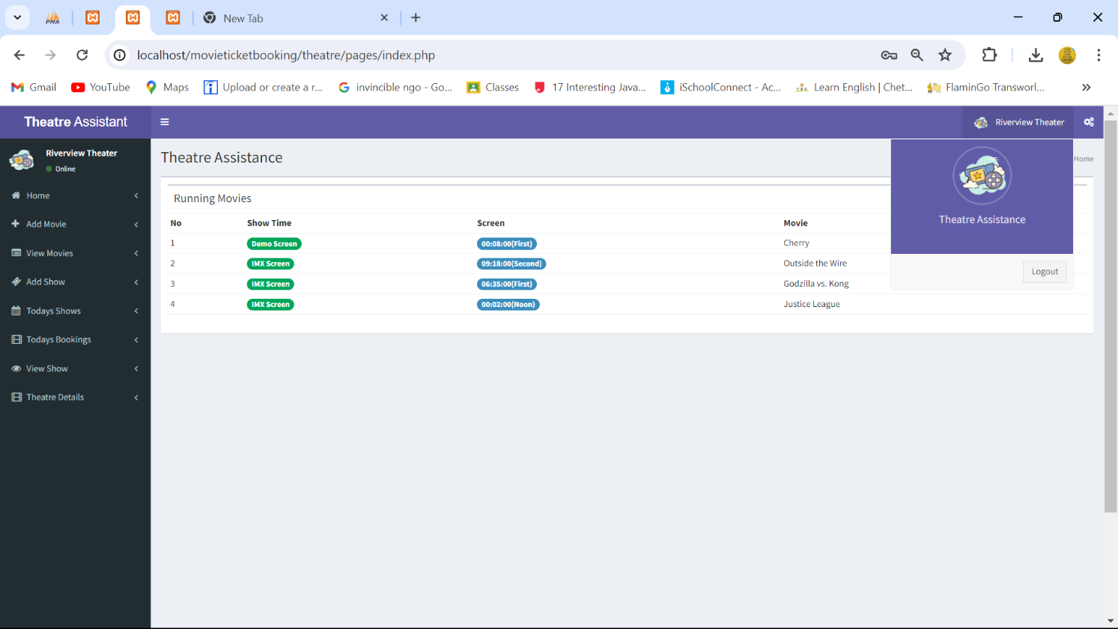

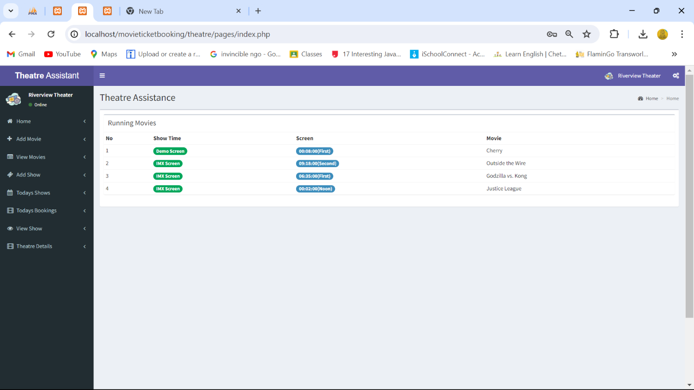



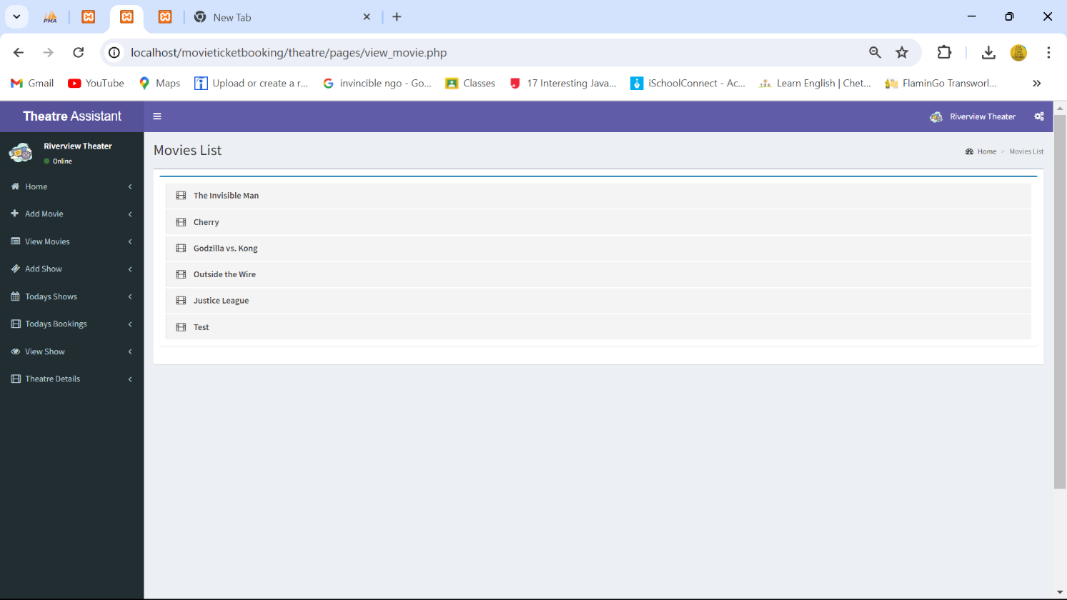

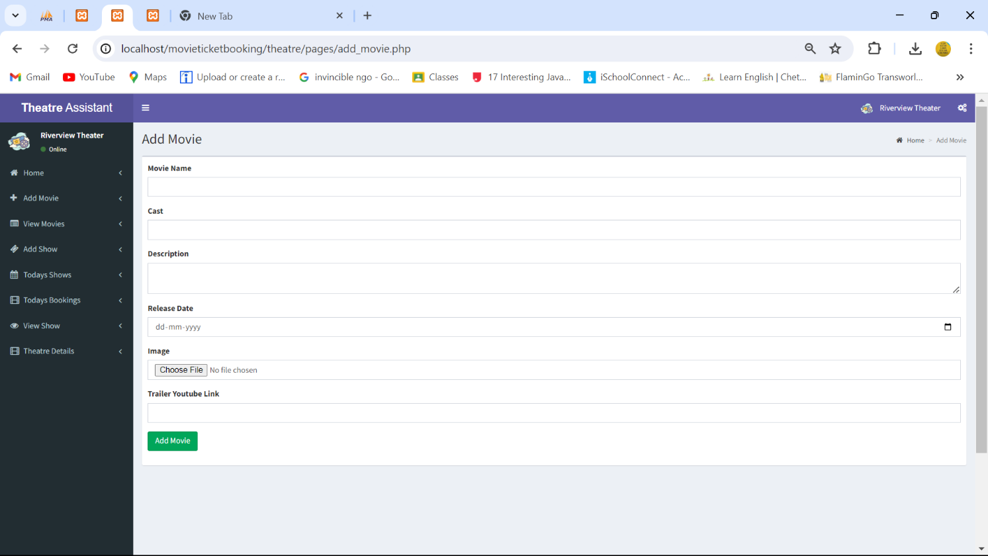

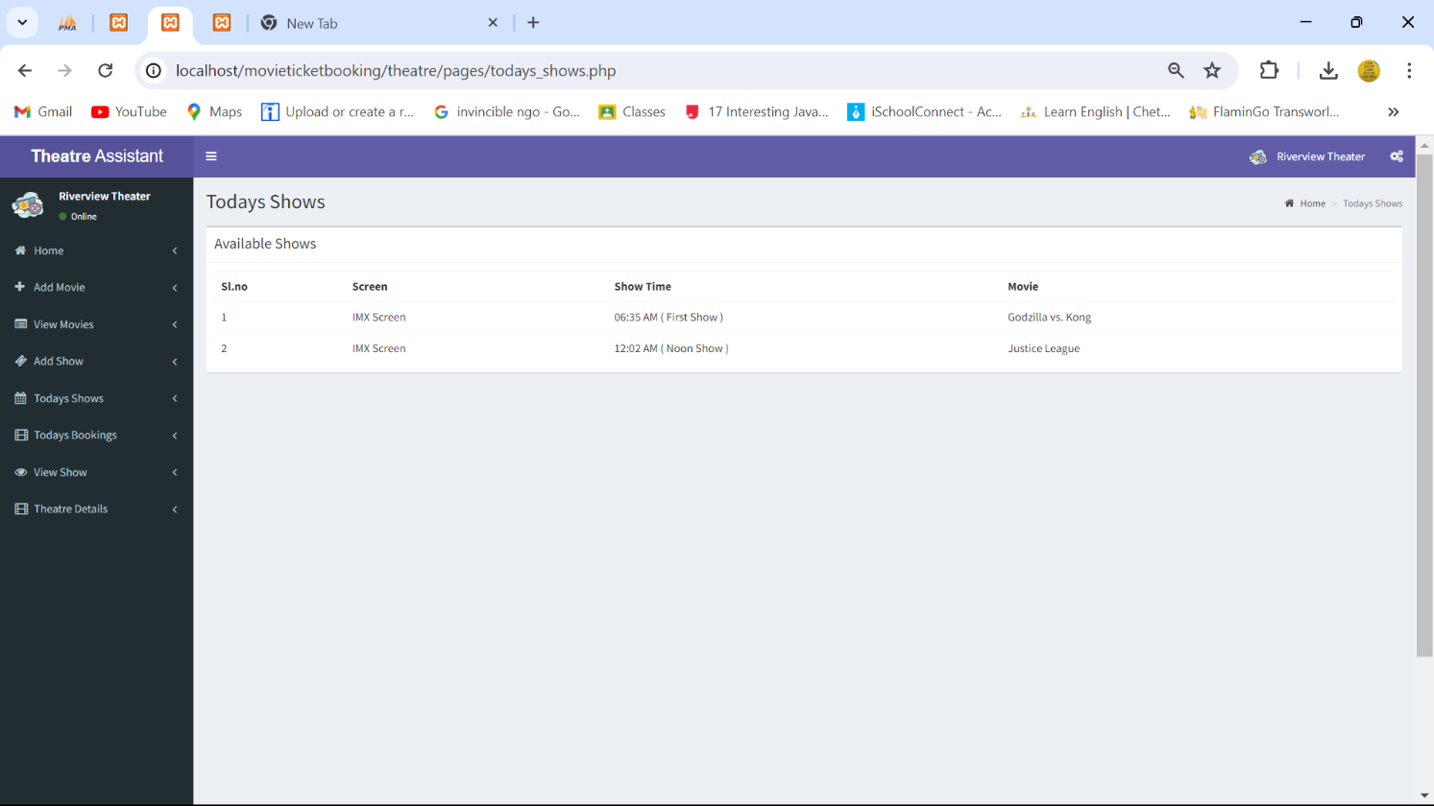

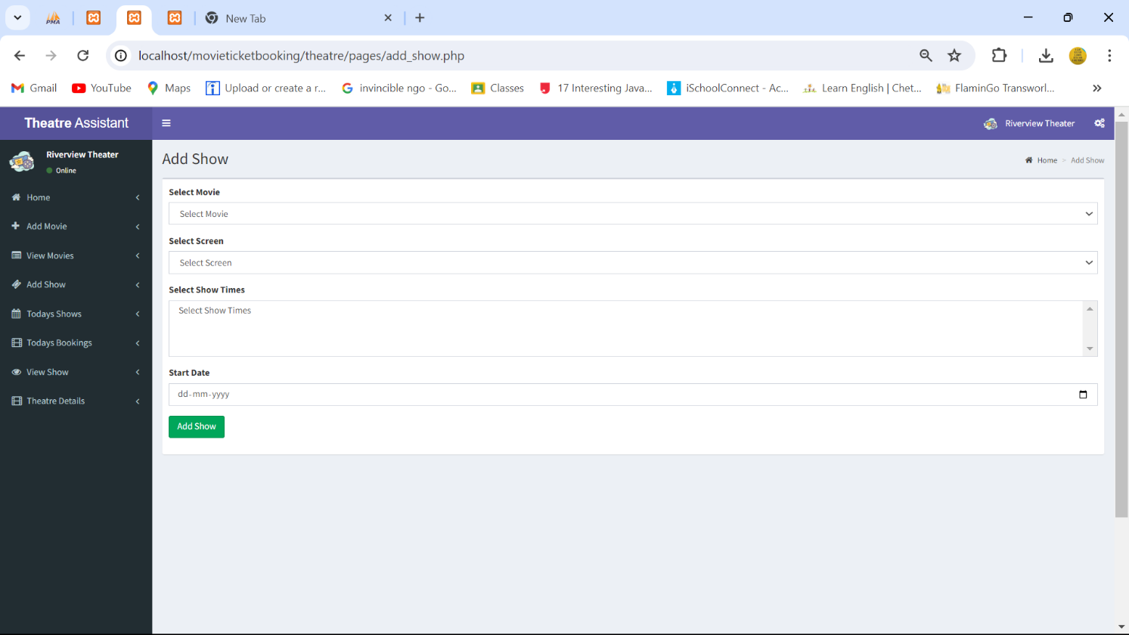

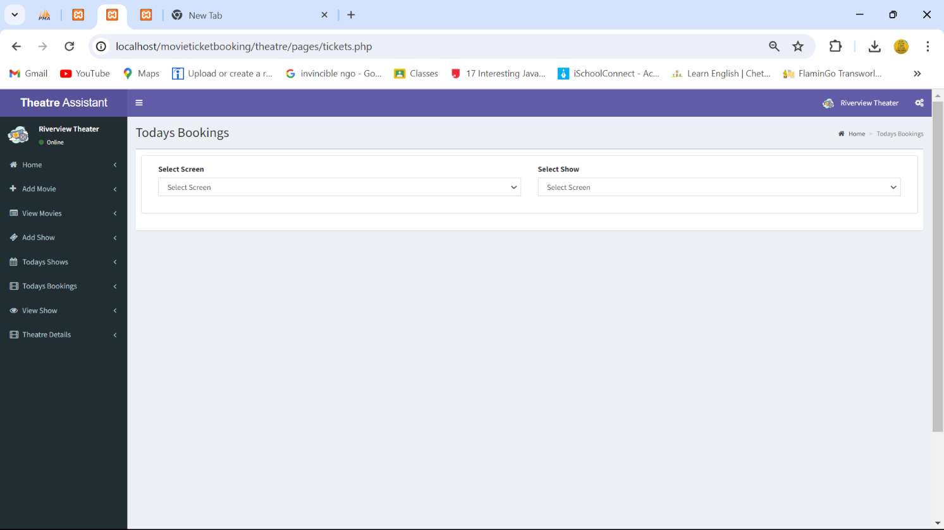

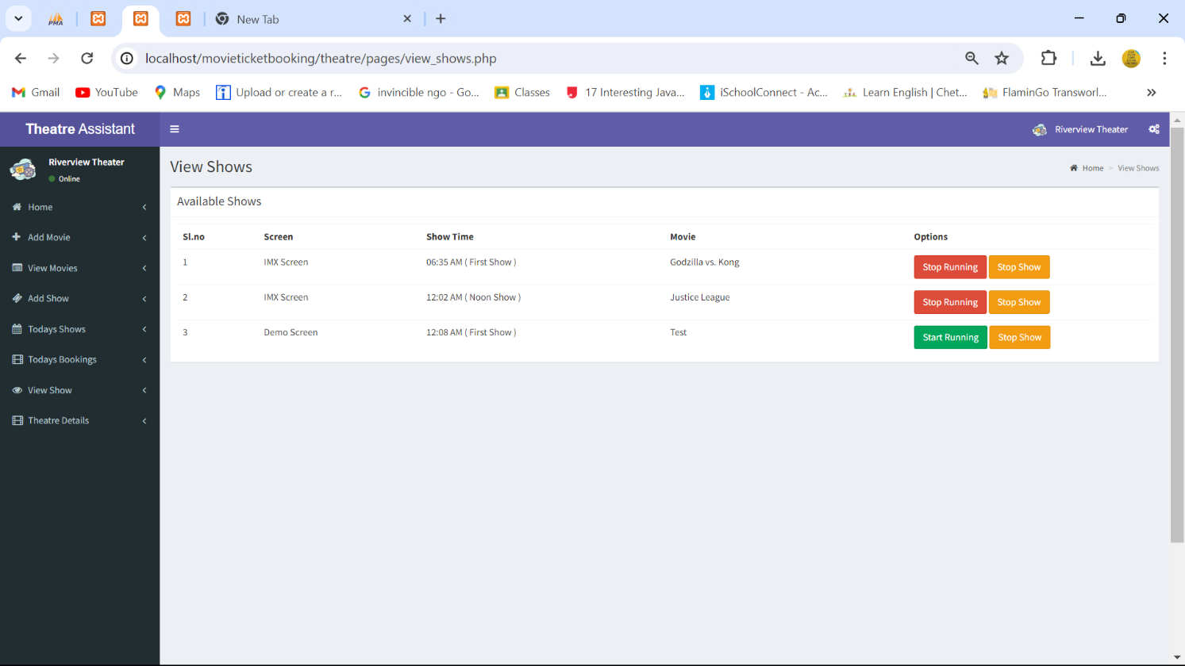

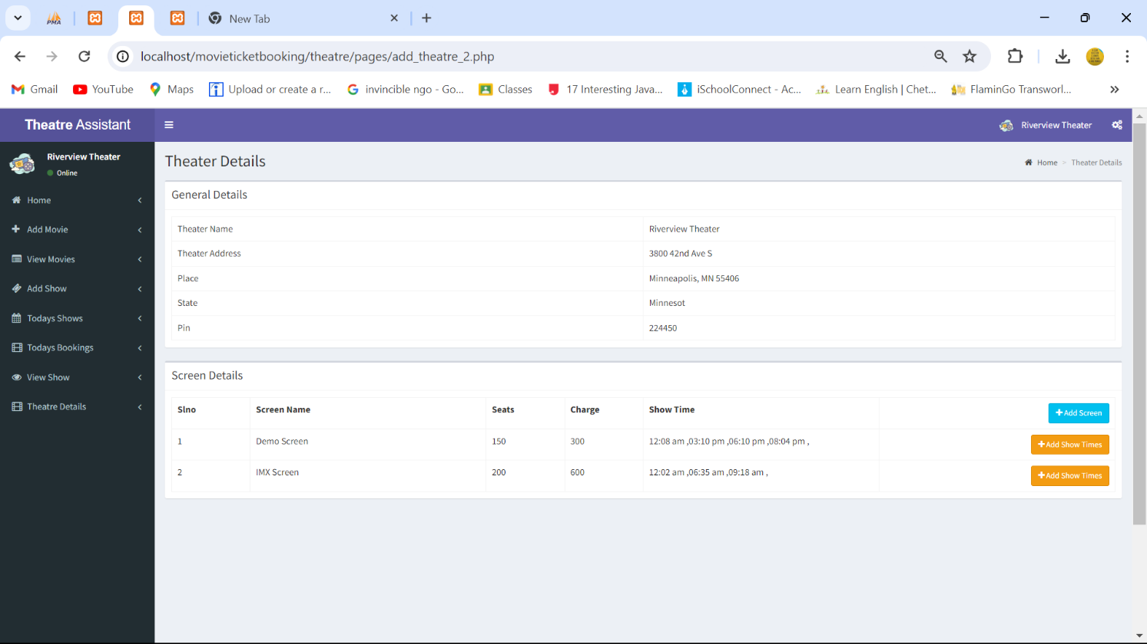

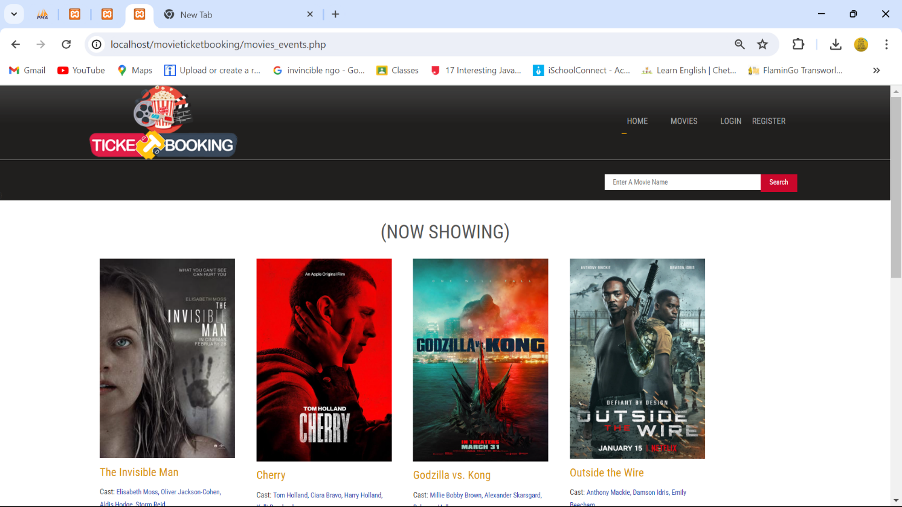

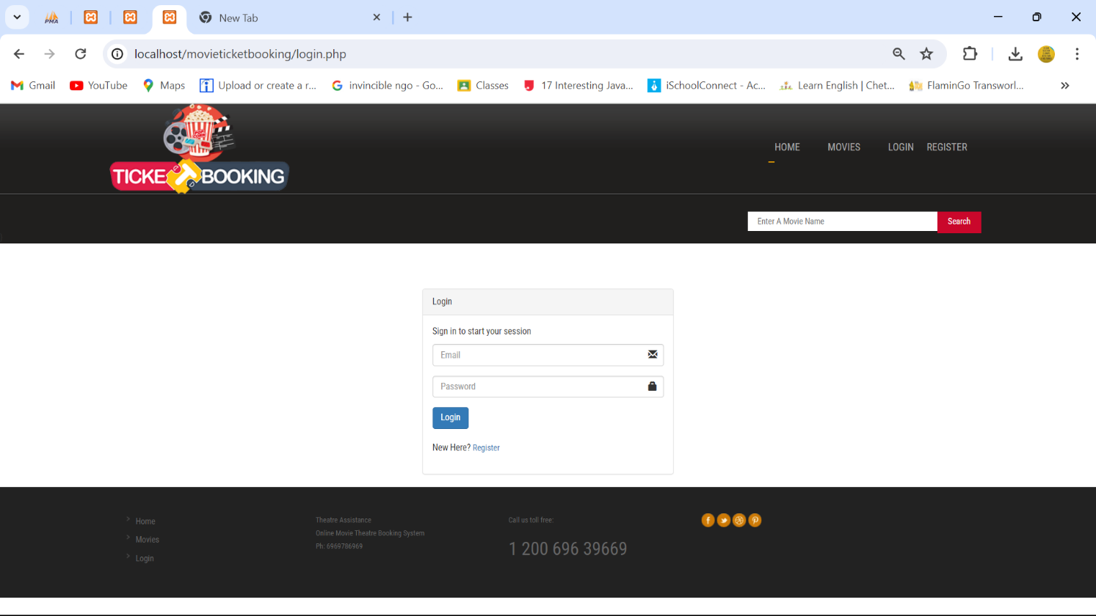

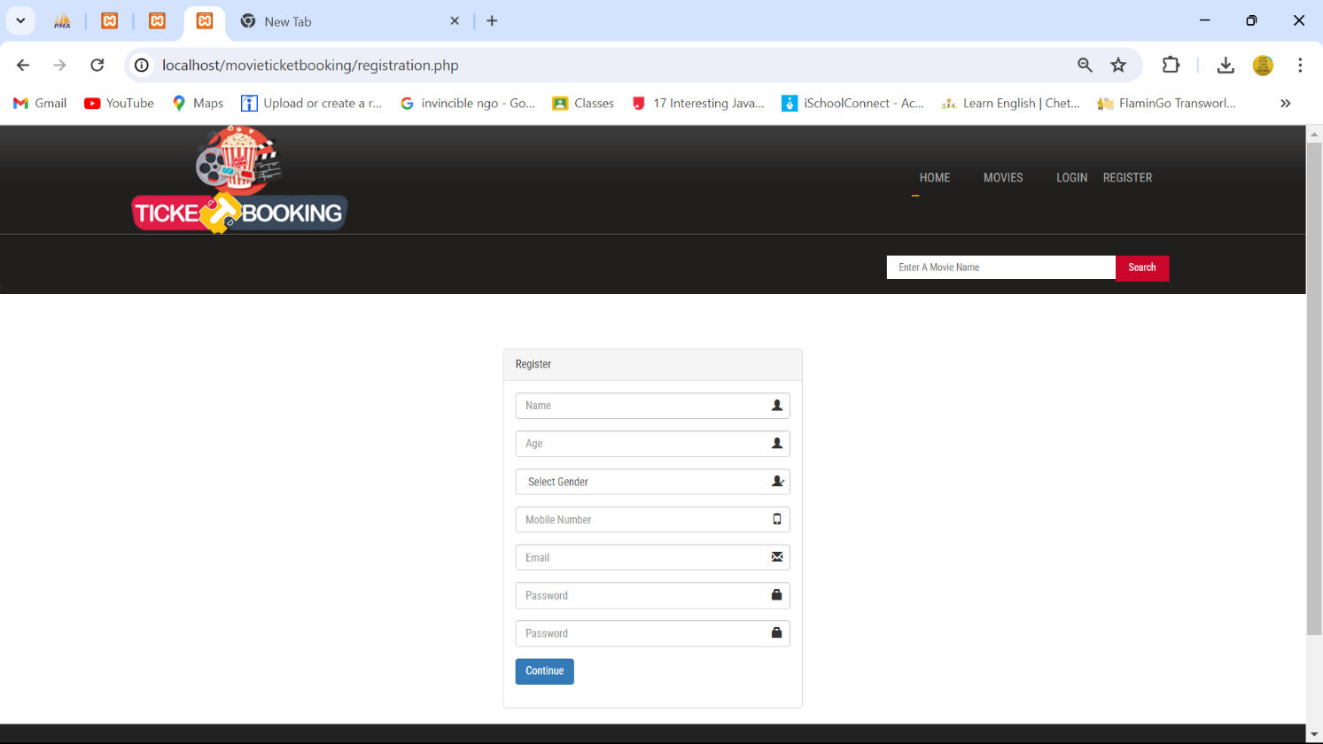

# Application

If you’re looking for project ideas for a Content Management System (CMS) application, here are a few suggestions:

* + **Blog Platform**: Create a CMS for blogging, with features for user profiles, comments, and likes.
  + **Event Management System:** Develop a system to organize and promote events through a user-friendly interface.
  + **Portfolio Website:** Build a CMS that allows users to create and manage their own portfolio websites to showcase work and achievements.

# Expected Outcomes:

For a CMS (Content Management System) project, the expected outcomes could include:

* + User-Friendly Interface: A CMS that is intuitive and easy to navigate for both administrators and end-users1.
  + Content Organization: Efficient categorization, tagging, and management of content to streamline the user experience1.
  + Customization and Flexibility: The ability to customize the look and functionality to meet specific user needs2.
  + Access Control: Robust user permissions and access control to ensure content security and integrity1.
  + Scalability: The system should be able to grow with the user’s needs, handling increased traffic and content without performance issues1.
  + SEO Optimization: Features that support search engine optimization to increase visibility and traffic2.
  + Analytics and Reporting: Tools to track user engagement and content performance to inform strategy1.
  + Multi-Platform Support: Compatibility with various devices and browsers for a consistent experience across platforms2.
  + These outcomes focus on delivering a CMS that not only manages content effectively but also enhances the overall digital experience for its users.

# Future Scope

The future scope for Content Management Systems (CMS) is quite promising and includes several key trends:

* + Omnichannel Experience: CMSs are evolving to provide a seamless content experience across multiple platforms and devices1.
  + Headless and Hybrid CMS: There’s a shift towards headless CMS, where the content repository is separated from the presentation layer, allowing for greater flexibility in content delivery2.
  + Content-First Approach: The focus is on creating content that can be easily accessed and used in different contexts, prioritizing the content over the design1.
  + AI and Machine Learning: Integration of AI to automate content personalization, improve search functionality, and enhance user experiences3.
  + Increased Demand for Digital Marketing Solutions: As digital marketing grows, so does the need for CMSs that can support complex marketing strategies3.
  + Growth in Digital Retail: E-commerce integration is becoming more prevalent in CMSs to support the growing digital retail sector3.
  + Enhanced Security: With the rise of cyber threats, CMSs will continue to develop stronger security measures to protect content and user data2.
  + These trends indicate that CMSs will continue to become more sophisticated, userfriendly, and integral to digital strategies in various industries.

# 12. References

BootstrapMade Impact Template:

https://bootstrapmade.com/impact-bootstrap-business-website-template/

BootstrapMade Impact Template:

https://bootstrapmade.com/nice-admin-bootstrap-admin-html-template/